Practical No.07 Roll no .07

Q. Design a program for creating a machine which accepts string having equal no. of 1’s and 0’s

code:
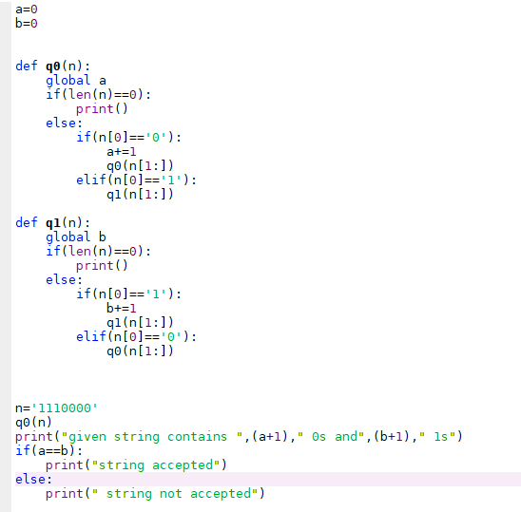

output:

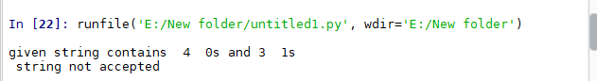

code:

output:
